**Problem 1**

#include "Polynomial.h"

#include <math.h>

double Polynomial::operator()(double aX) const {

double lResult = 0;

for (int i = fDegree; i >= 0; i--)

{

lResult += fCoeffs[i] * pow(aX, i);

}

return lResult;

}

Polynomial Polynomial::getDifferential() const {

Polynomial lResult;

for (int i = fDegree; i >= 0; i--)

{

lResult.fCoeffs[i - 1] = fCoeffs[i] * i;

}

if (fDegree - 1 >= 0)

{

lResult.fDegree = fDegree - 1 <= MAX_POLYNOMIAL ? fDegree - 1 : MAX_POLYNOMIAL;

}

else

{

lResult.fDegree = 0;

}

return lResult;

}

Polynomial Polynomial::getIndefiniteIntegral() const {

Polynomial lResult;

if (fDegree + 1 <= MAX_POLYNOMIAL)

{

lResult.fDegree = fDegree + 1;

}

else

{

lResult.fDegree = MAX_POLYNOMIAL;

}

for (int i = lResult.fDegree - 1; i >= 0; i--)

{

lResult.fCoeffs[i + 1] = fCoeffs[i] / ((double)i + 1);

}

return lResult;

}

double Polynomial::getDefiniteIntegral(double aXLow, double aXHigh) const {

double lLow = 0;

double lHigh = 0;

for (int i = fDegree; i >= 0; i--)

{

lLow += fCoeffs[i] / ((double) i + 1) * pow(aXLow, i + 1);

}

for (int i = fDegree; i >= 0; i--)

{

lHigh += fCoeffs[i] / ((double)i + 1) * pow(aXHigh, i + 1);

}

return lHigh - lLow;

}

**Output**

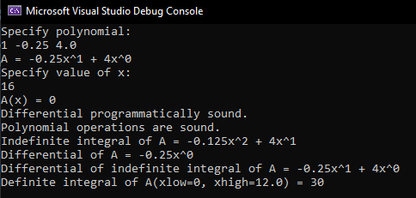

**Problem 2**

#include "Combination.h"

Combination::Combination(unsigned int aN, unsigned int aK) {

fN = aN;

fK = aK;

}

unsigned int Combination::getN() const {

return fN;

}

unsigned int Combination::getK() const {

return fK;

}

unsigned long long Combination::operator()() const {

if (fK > fN) return 0;

if (fK == fN) return 1;

unsigned long long lResult = 1;

for (int k = 1; k <= fK; k++)

{

lResult *= ((unsigned long long)fN - k + 1);

lResult /= k;

}

return lResult;

}

**Output**

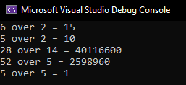

**Problem 3**

#include "BernsteinBasePolynomial.h"

#include <math.h>

BernsteinBasePolynomial::BernsteinBasePolynomial() : fFactor(0, 0) {}

BernsteinBasePolynomial::BernsteinBasePolynomial(unsigned int aV, unsigned int aN) : fFactor(aN, aV) {}

double BernsteinBasePolynomial::operator()(double aX) const {

return fFactor() * pow(aX, fFactor.getK()) * pow((1 - aX), (fFactor.getN() - fFactor.getK()));

}

**Output**

